**[Healthy Plants – Healthy People](https://healthyplantshealthypeople.com/" \t "_self)**

# **GROW YOUR OWN BIO-BOOSTER**

**BREWING & APPLICATION**

By Trevor Galletly[[1]](#endnote-1) Peter Van Beek1, V 3 – Jan 2025

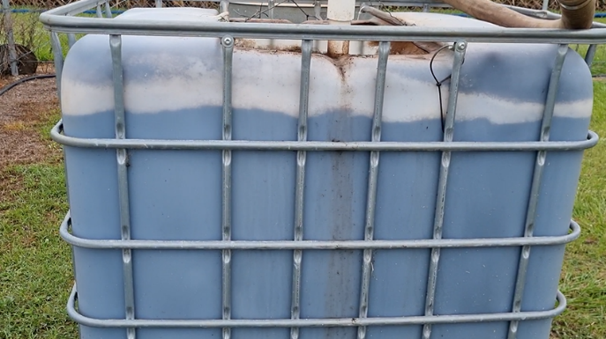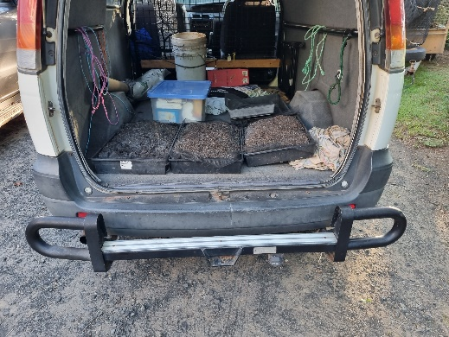

Delivery of Starter Brewing

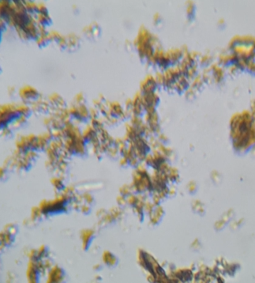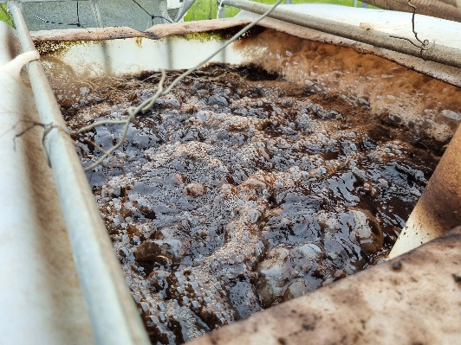

Surface of Brew Microscope Checking

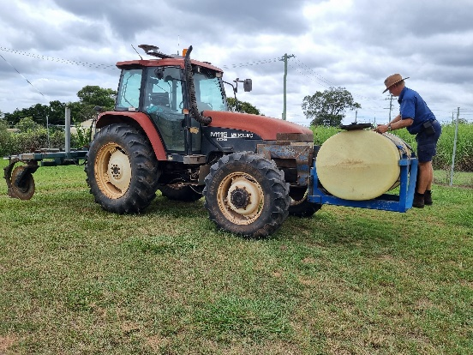

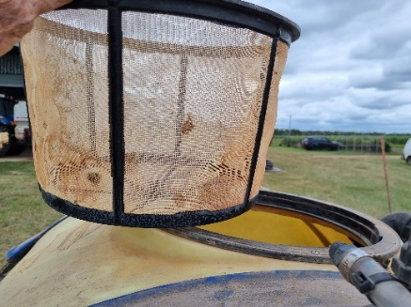

Preparation of Tractor tank Tank Sieve

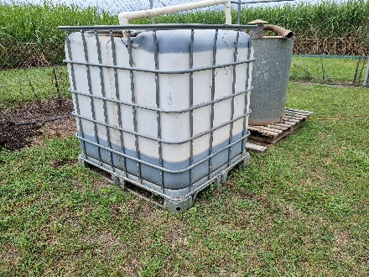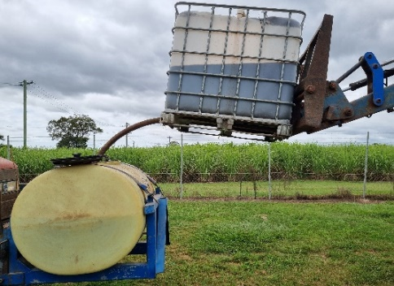

Gravity transfer of

Bio-Booster

Remainder of Bio-Booster aerating for

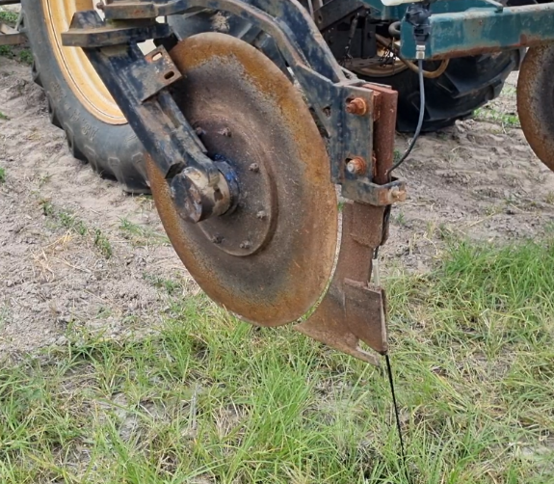 application tomorrow

Testing of Bio-Booster application

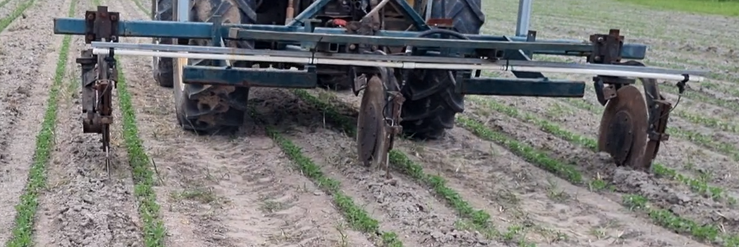

3 Row application behind coulters

Make a Record of trial rows without bio-Booster - remainder Treated

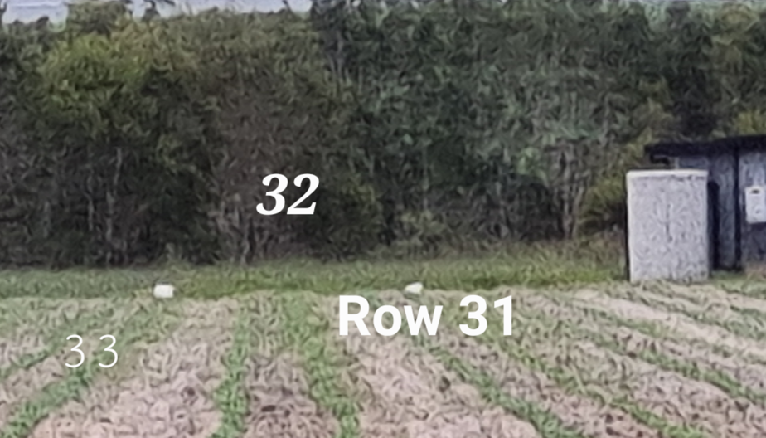

1. Trevor Galletly, *QDA, B AgSC - 40 years in biological farming* Peter van Beek, *Dip Agr, B Ec, M Ag studie* [↑](#endnote-ref-1)