Good and Bad Ladybird Beetles

Fourteen-spotted ladybug GOOD GUYS
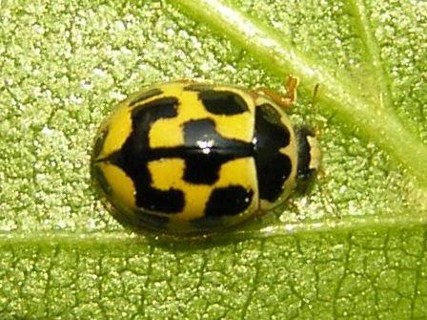
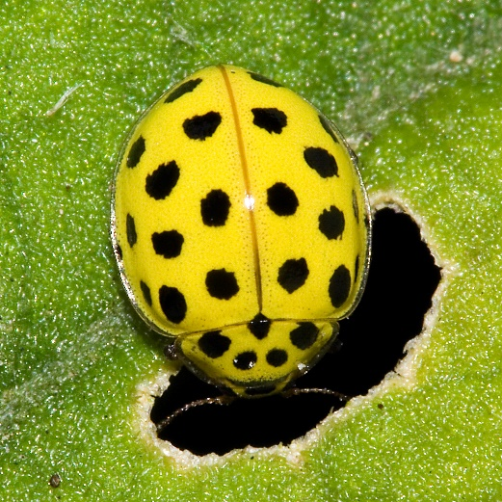

28-spotted ladybird BAD GUYS

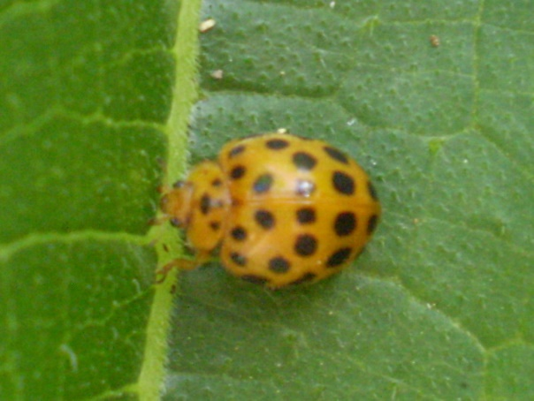
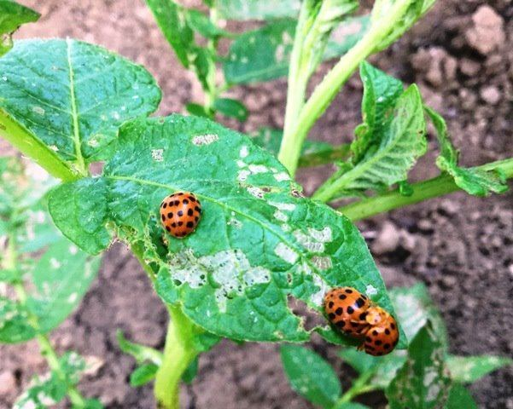

Ladybirds

From ABC Gardening Australia

SERIES 18 | Episode 13
Most gardeners would recognise a brightly coloured ladybird in their gardens. There are over 100 species in Australia and the vast majority are beneficial, but it pays to know the difference between the good and the bad - beware the vegetarians!
Ladybirds are also known as ladybugs or ladybeetles. The adults are oval domed in form and range in length from 1 to 10mm, depending on the species. Female ladybirds are larger than the males and their hard, colourful forewings cover the membranous hind wings and they also serve to protect the abdomen of the insect. Both their legs and their clubbed antennae are short and usually withdrawn beneath their bodies when they're disturbed.
Most ladybirds are brightly coloured and that's a warning, a signal to potential predators that they may be toxic. If they're scared they can exude a yellow liquid which is foul tasting. As a final precaution, a final defence, they may drop to the ground or fly away.
There are four common garden species of ladybird in Australia. The common spotted ladybird is bright orange with black dots on its back. They're voracious predators of aphids, scale insects and mites. Adults will consume 2,500 aphids during their life.
The fungus eating ladybird has very bold black and yellow colouration. Both adults and larvae feed on mildew fungus, which is a really common problem in gardens.
The villain is the 28 spotted or leaf eating ladybird. They're easy to identify. Adults are up to 1cm long, a light orange colour and they have 28 spots. Both adults and larvae feed on a range of plants - cabbage, potato and bean family are preferred foods. The larvae are easy to recognise because they are yellowish creamy colour, with a frizzy outline and they feed on the undersides of the leaves.
The best way to control leaf eating ladybirds is to handpick them from plants. Smaller outbreaks of powdery mildew on plants like pumpkins will be controlled by the fungus eating ladybird. For larger outbreaks spray plants with one part fresh milk to five parts water and repeat this weekly. The benefit of using milk and water is that it will control fungus without harming any of the useful ladybirds. Another tip for controlling the leaf eating ladybird is to control a weed called blackberry nightshade. It's a favourite food plant and quite often infestations start on the weed before they move into the garden. Just pull it out and then you won't have so many problems with precious vegetables.
https://www.abc.net.au/gardening/factsheets/ladybirds/9427770

